PROGRAM -1

1. import java.util.Arrays;
2.
3. public class ConvertBTtoBST {
4.
- //Represent a node of binary tree
- public static class Node{
- int data;
- Node left; 9. Node right;
10.
- public Node(int data){
- //Assign data to the new node, set left and right children to null
- this.data = data;
- this.left = null;
- this.right = null;
- } 17. }
18.
19. //Represent the root of binary tree 20. public Node root;
21.
22. int[] treeArray; 23. int index = 0;
24.
- public ConvertBTtoBST(){
- root = null; 27. }
28.
- //convertBTBST() will convert a binary tree to binary search tree
- public Node convertBTBST(Node node) {
31.
- //Variable treeSize will hold size of tree
- int treeSize = calculateSize(node);
- treeArray = new int[treeSize];
35.
- //Converts binary tree to array
- convertBTtoArray(node);
38.
39. //Sort treeArray 40. Arrays.sort(treeArray);
41.
- //Converts array to binary search tree
- Node d = createBST(0, treeArray.length -1);
- return d; 45. }
46.
- //calculateSize() will calculate size of tree
- public int calculateSize(Node node)
- {
- int size = 0;
- if (node == null)
- return 0;
- else {
- size = calculateSize (node.left) + calculateSize (node.right) + 1;
- return size;
- } 57. }
58.
- //convertBTtoArray() will convert the given binary tree to its corresponding array representati on
- public void convertBTtoArray(Node node) {
- //Check whether tree is empty
- if(root == null){
- System.out.println("Tree is empty");
- return;
- }
- else {
- if(node.left != null)
- convertBTtoArray(node.left);
- //Adds nodes of binary tree to treeArray
- treeArray[index] = node.data;
- index++;
- if(node.right != null)
- convertBTtoArray(node.right);
- } 75. }
76.
- //createBST() will convert array to binary search tree
- public Node createBST(int start, int end) {
79.
- //It will avoid overflow
- if (start > end) {
- return null; 83. }
84.
- //Variable will store middle element of array and make it root of binary search tree
- int mid = (start + end) / 2;
- Node node = new Node(treeArray[mid]);
88.
- //Construct left subtree
- node.left = createBST(start, mid - 1);
91.
- //Construct right subtree
- node.right = createBST(mid + 1, end);
94.
95. return node; 96. }
97.
- //inorder() will perform inorder traversal on binary search tree
- public void inorderTraversal(Node node) {
100.
- //Check whether tree is empty
- if(root == null){
- System.out.println("Tree is empty");
- return;
- } 106. else {
107.
- if(node.left!= null)
- inorderTraversal(node.left);
- System.out.print(node.data + " ");
- if(node.right!= null) 112. inorderTraversal(node.right);
113.
- }
- }
116.
117. public static void main(String[] args) {
118.
- ConvertBTtoBST bt = new ConvertBTtoBST();
- //Add nodes to the binary tree
- bt.root = new Node(1);
- bt.root.left = new Node(2);
- bt.root.right = new Node(3);
- bt.root.left.left = new Node(4);
- bt.root.left.right = new Node(5);
- bt.root.right.left = new Node(6); 127. bt.root.right.right = new Node(7);
128.
- //Display given binary tree
- System.out.println("Inorder representation of binary tree: ");
- bt.inorderTraversal(bt.root);
132.
- //Converts binary tree to corresponding binary search tree
- Node bst = bt.convertBTBST(bt.root);
135.
- //Display corresponding binary search tree
- System.out.println("\nInorder representation of resulting binary search tree: ");
- bt.inorderTraversal(bst);
- }
- }

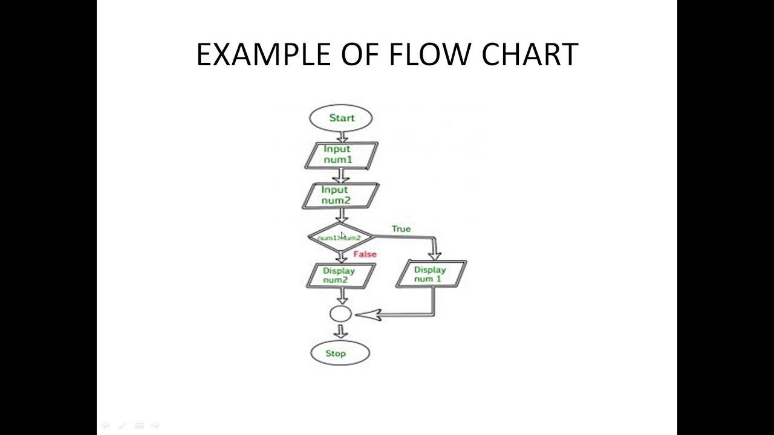

PROGRAM-2

1. public class RotateList {
2.
3. //Represent a node of the doubly linked list
4.
- class Node{
- int data;
- Node previous;
- Node next;
9.
- public Node(int data) {
- this.data = data;
- }
- }
14.
- int size = 0;
- //Represent the head and tail of the doubly linked list
- Node head, tail = null;
18.
- //addNode() will add a node to the list
- public void addNode(int data) {
- //Create a new node
- Node newNode = new Node(data);
23.
- //If list is empty
- if(head == null) {
- //Both head and tail will point to newNode
- head = tail = newNode;
- //head's previous will point to null
- head.previous = null;
- //tail's next will point to null, as it is the last node of the list
- tail.next = null;
- }
- else {
- //newNode will be added after tail such that tail's next will point to newNode
- tail.next = newNode;
- //newNode's previous will point to tail
- newNode.previous = tail;
- //newNode will become new tail
- tail = newNode;
- //As it is last node, tail's next will point to null
- tail.next = null;
- }
- //Size will count the number of nodes present in the list
- size++;
- }
46.
- //rotateList() will rotate the list by given n nodes
- public void rotateList(int n) {
- //Initially, current will point to head
- Node current = head;
51.
- //n should not be 0 or greater than or equal to number of nodes present in the list
- if(n == 0 || n >= size)
- return;
- else {
- //Traverse through the list till current point to nth node
- //after this loop, current will point to nth node
- for(int i = 1; i < n; i++) 59. current = current.next;
60.
- //Now to move entire list from head to nth node and add it after tail
- tail.next = head;
- //Node next to nth node will be new head
- head = current.next;
- //Previous node to head should be null
- head.previous = null;
- //nth node will become new tail of the list
- tail = current;
- //tail's next will point to null
- tail.next = null;
- }
- }
73.
- //display() will print out the nodes of the list
- public void display() {
- //Node current will point to head
- Node current = head;
- if(head == null) {
- System.out.println("List is empty");
- return;
- }
- while(current != null) {
- //Prints each node by incrementing the pointer.
84.
- System.out.print(current.data + " ");
- current = current.next;
- }
- System.out.println();
- }
90.
91. public static void main(String[] args) {
92.
- RotateList dList = new RotateList();
- //Add nodes to the list
- dList.addNode(1);
- dList.addNode(2);
- dList.addNode(3);
- dList.addNode(4);
- dList.addNode(5);
100.
- System.out.println("Original List: ");
- dList.display();
103.
- //Rotates list by 3 nodes
- dList.rotateList(3);
106.
- System.out.println("Updated List: ");
- dList.display();
- }
- }

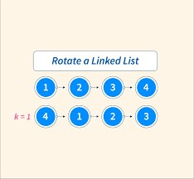

PROGRAM -3

- public class changeCase {
- public static void main(String[] args) {
3.
- String str1="Great Power";
- StringBuffer newStr=new StringBuffer(str1);
6.
7. for(int i = 0; i < str1.length(); i++) {
8.
- //Checks for lower case character
- if(Character.isLowerCase(str1.charAt(i))) {
- //Convert it into upper case using toUpperCase() function
- newStr.setCharAt(i, Character.toUpperCase(str1.charAt(i)));
- }
- //Checks for upper case character
- else if(Character.isUpperCase(str1.charAt(i))) {
- //Convert it into upper case using toLowerCase() function
- newStr.setCharAt(i, Character.toLowerCase(str1.charAt(i)));
- }
- }
- System.out.println("String after case conversion : " + newStr);
- }
- }

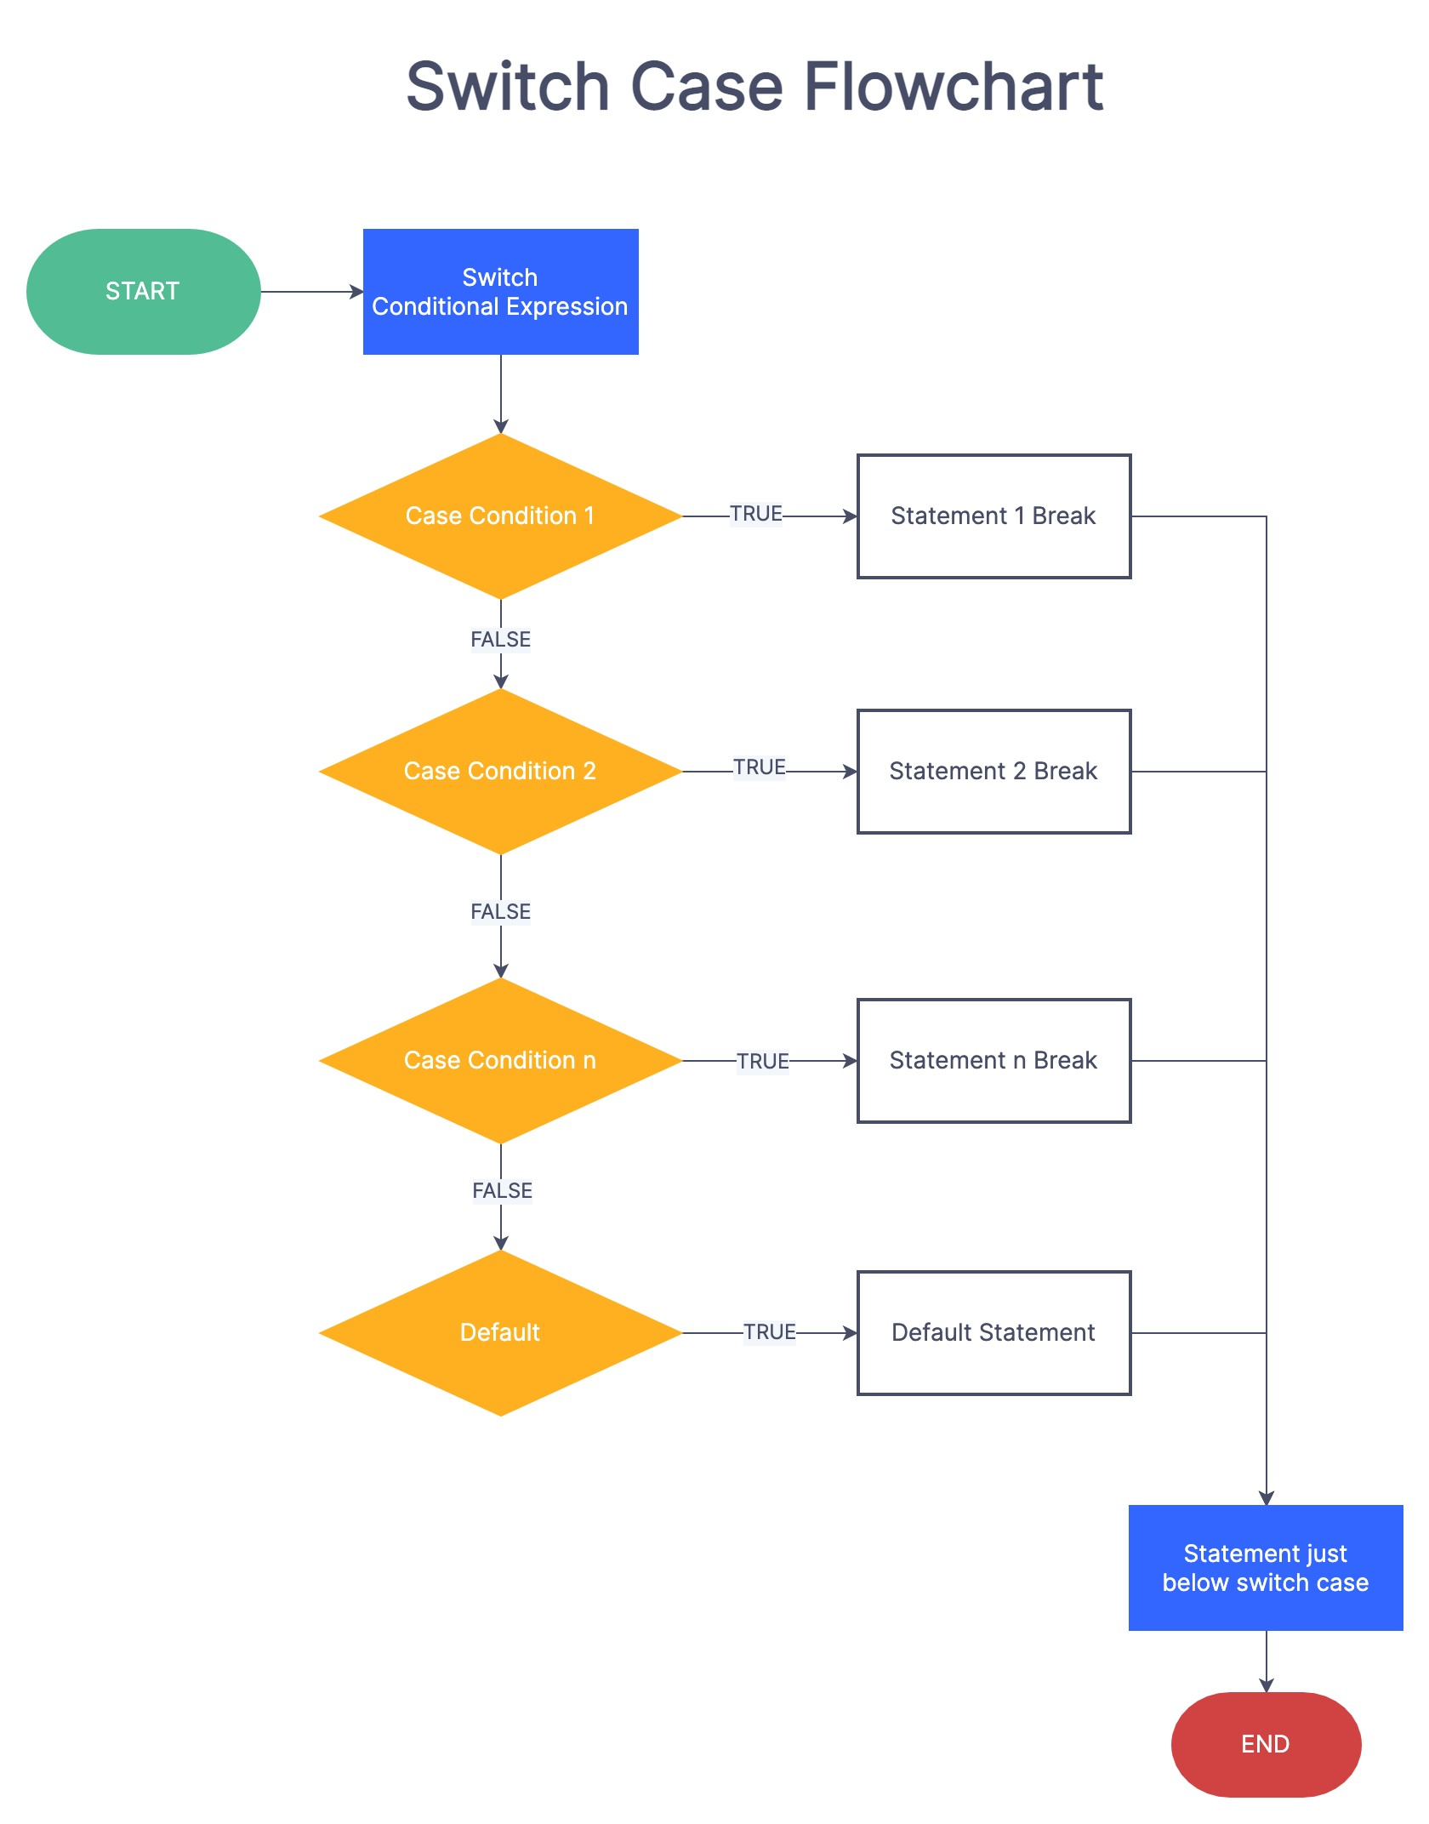

PROGRAM -4

- public class pattern
- {
- public static void main(String[] args){
- int lines=4;
- int i,j;
- for(i=1;i<=lines;i++){// this loop is used to print lines
- for(j=1;j<=lines;j++){// this loop is used to print * in a line
- if(i==j)
- System.out.print("*");
- else
- System.out.print("0");
- }
- j--;
- System.out.print("*");
- while(j>=1){// this loop is used to print * in a line
- if(i==j)
- System.out.print("*");
- else
- System.out.print("0");
- j--;
- }
- System.out.println("");
- }
- }
- } 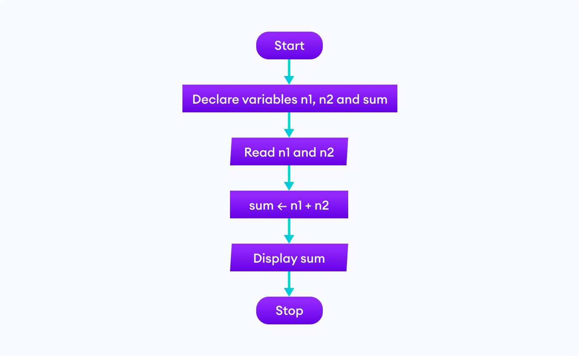

PROGRAM -5

- class PalindromeExample{
- public static void main(String args[]){
- int r,sum=0,temp;
- int n=454;//It is the number variable to be checked for palindrome
- temp=n;
- while(n>0){
- r=n%10; //getting remainder
- sum=(sum*10)+r;
- n=n/10;
- }
- if(temp==sum)
- System.out.println("palindrome number ");
- else
- System.out.println("not palindrome");
- }
- }

